Optically Interconnected Processor Array with Switching Capability

Zicheng Guo
Journal of Parallel and Distributed Computing 23,314-329(1994)
- Introduction
bwcg < Do
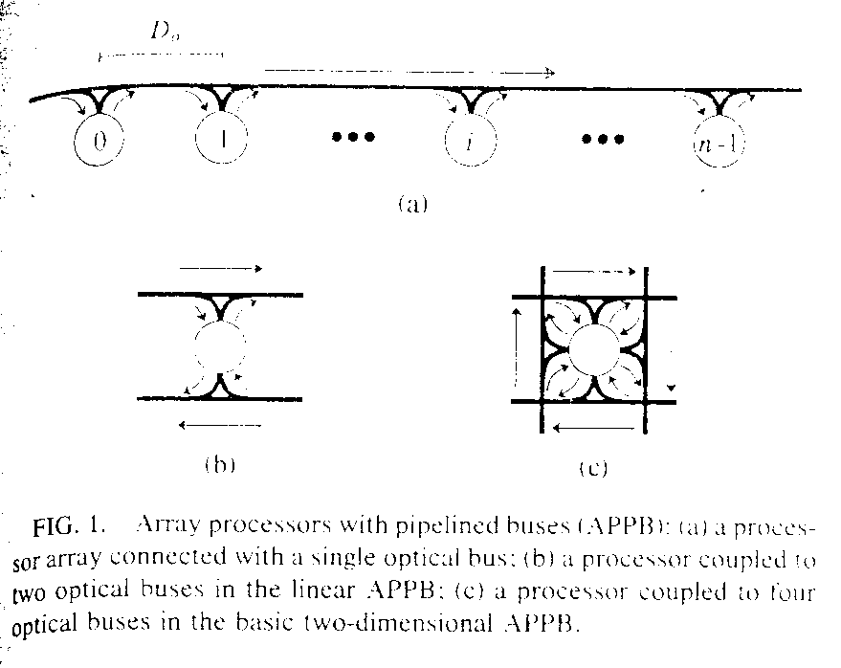
wait(i) = T(i,j) + send(j)
- Array Processors with Pipelined Buses using Switches
  - The Architecture of APPBS
The architecture of APPBS is the same as that of the basic two-dimensional APPB,except that optical switches are used at intersections of buses.
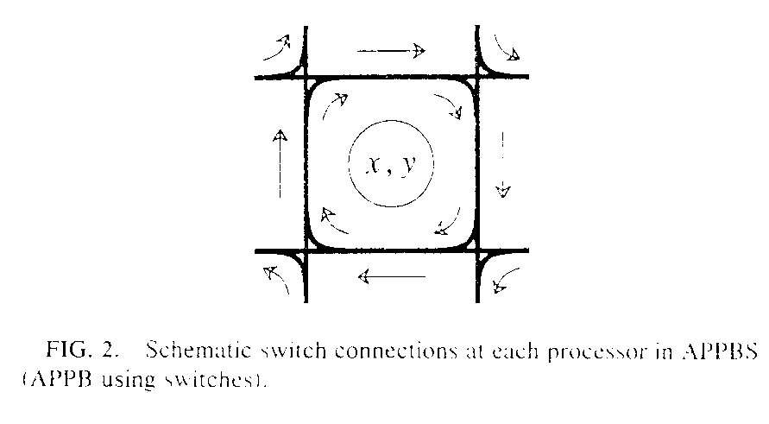
wait(xi,yi) = T((xi,yi),(xj,yj)) + send(xj,yj)
  - Collision-Free Communications in APPBS
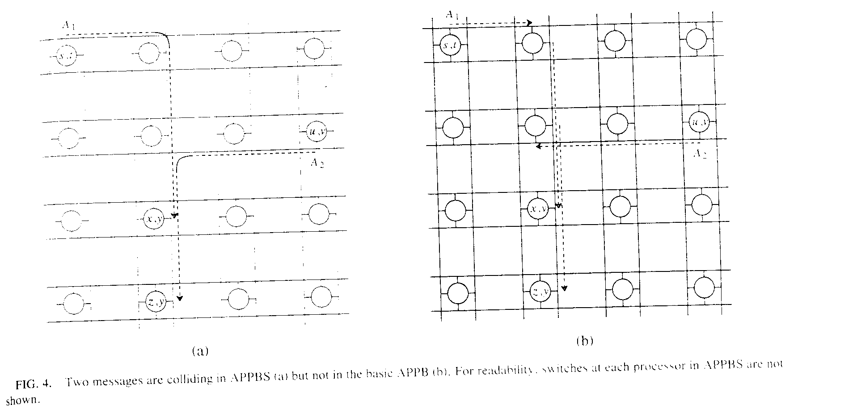
Then,in APPBS two message from two distince processors (s,t) and (u,v),respectively, with their paths passing the same bus at processor (x,y) will collide at (x,y) iff
|s – x| + |t – y| = |u – x| + |v – y|
  - APPBS with Partial Switching Capability
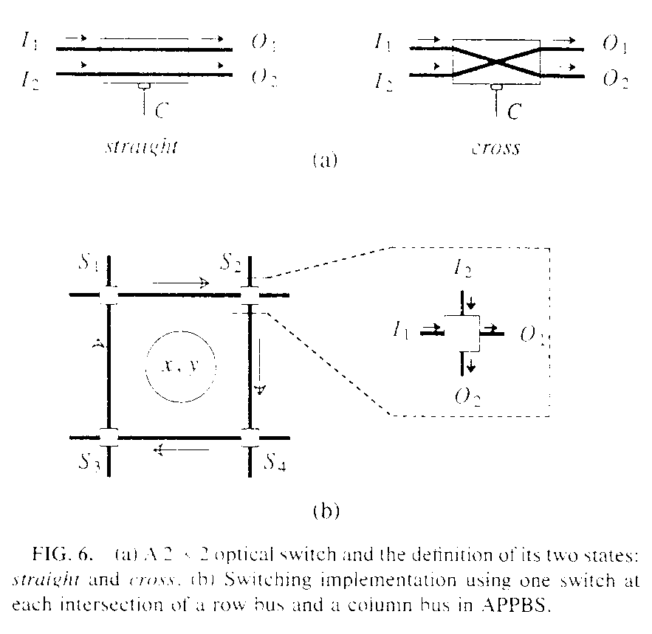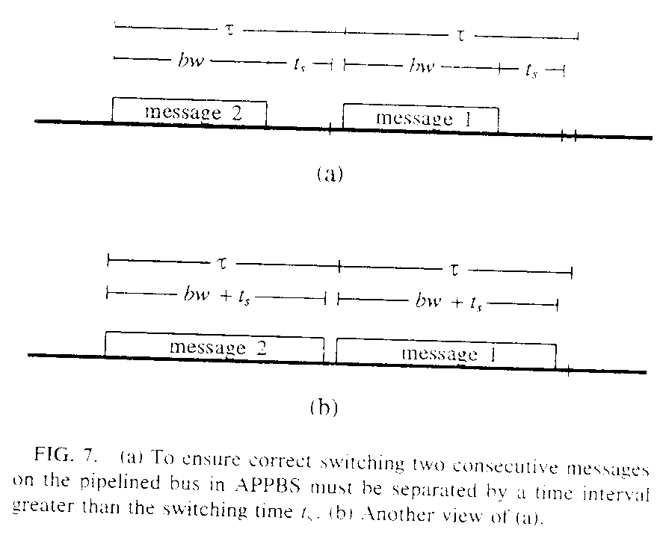
τ: a petit cycle
τ= Do/cg
bw + ts <τ
- Efficient Communications in APPBS
  - Matrix Transpose
Matrix transpose is useful for some important matrix computations such as multiplication.
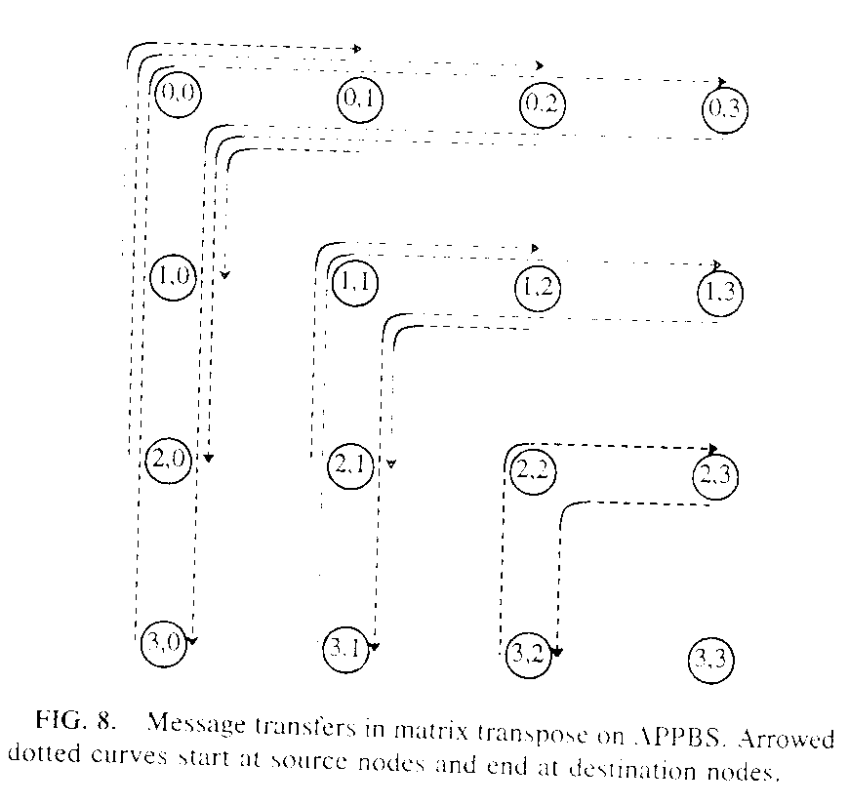
wait(x,y) = 2|x – y|, x≠y
  - Binary Tree Routing
Binary trees are among the most attractive communication structures for parallel processing and many efficient parallel algorithms for various applications have been proposed for them.
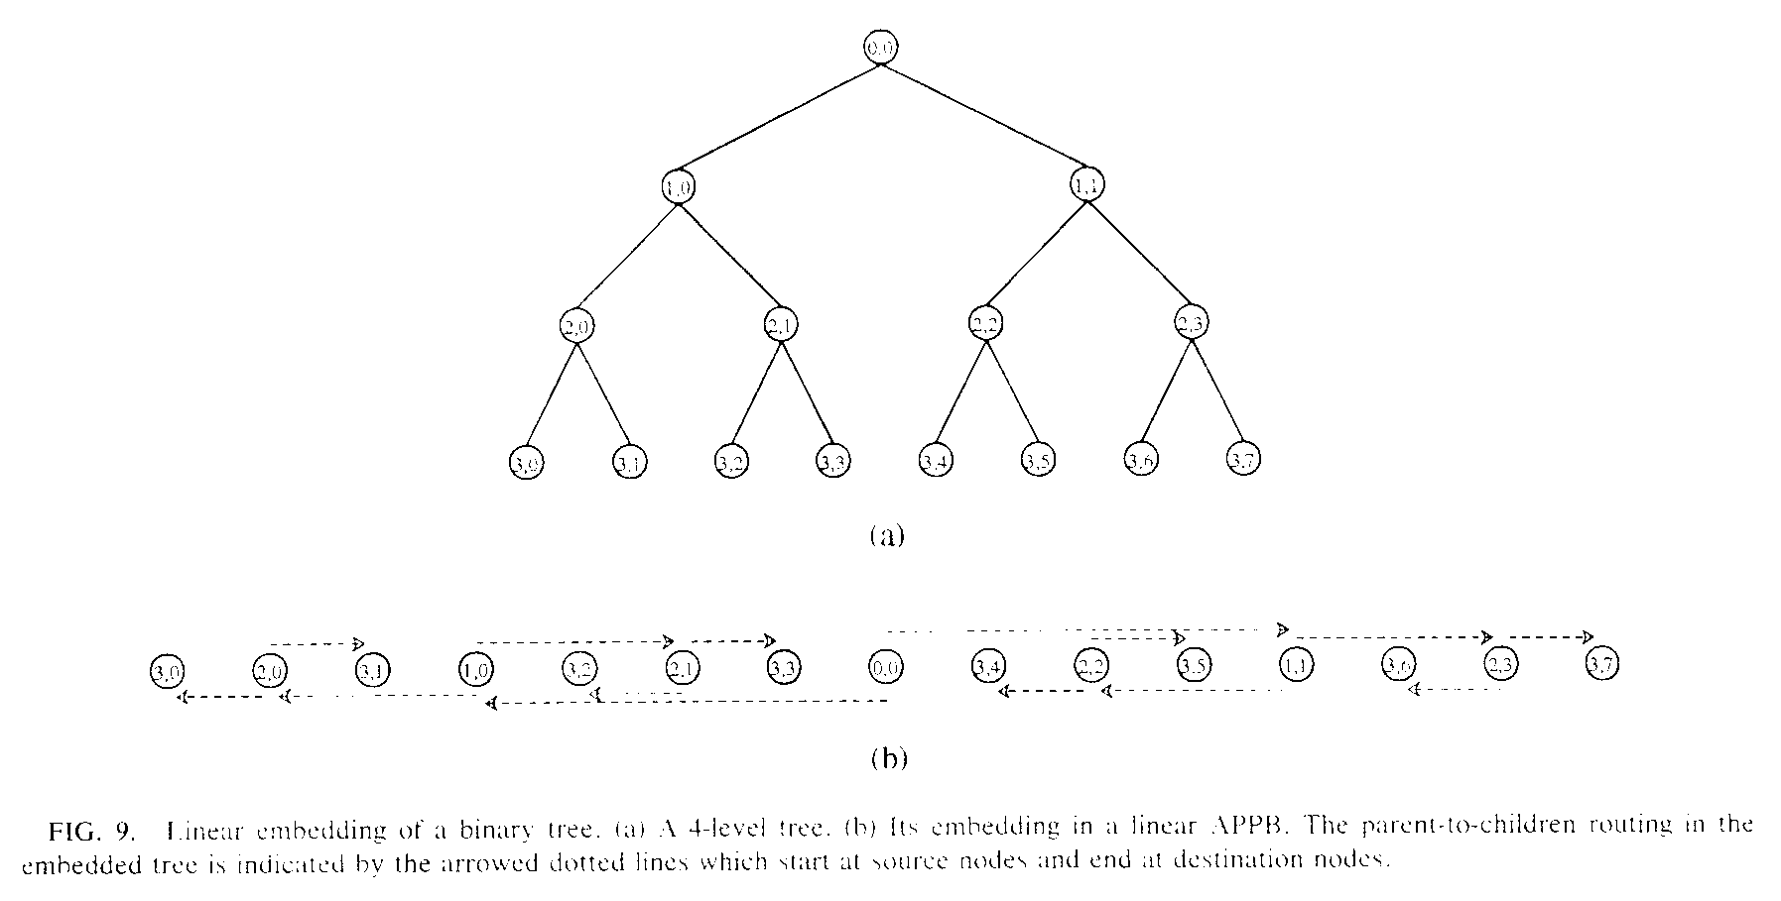
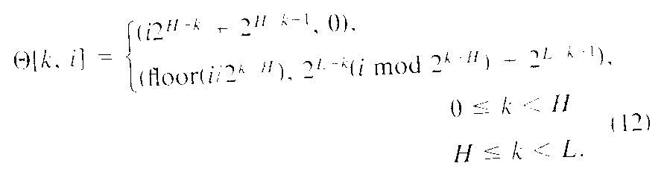
sendp,r[H –1, i] = 0, 0≦I < 2^(H-1)
sendp,l[H –1, i] = 1, 0≦I < 2^(H-1)

waitp,r[H, 2i + 1] = n/2, 0≦I < 2^(H-1)
waitp,l[H, 2i] = 2 + n/2, 0≦I < 2^(H-1)
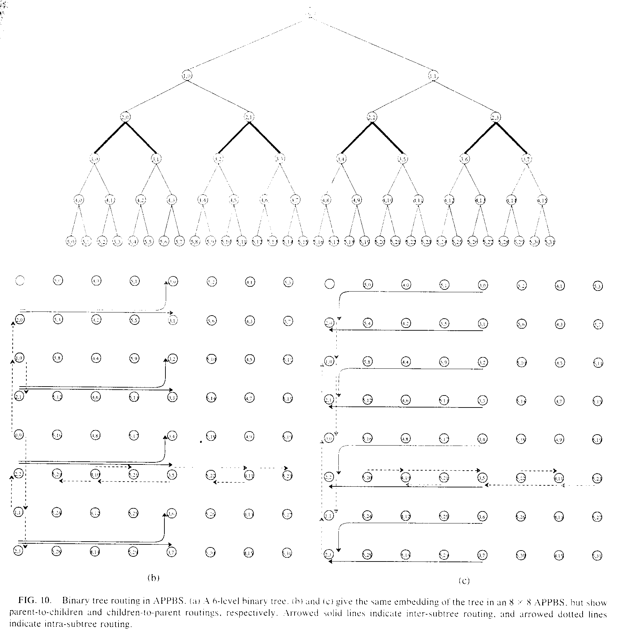
  - Perfect Shuffle
The perfect shuffle is another well-known communication structure which has been used in the design of many parallel algorithms including FFT, sorting, matrix operations, and image computations.
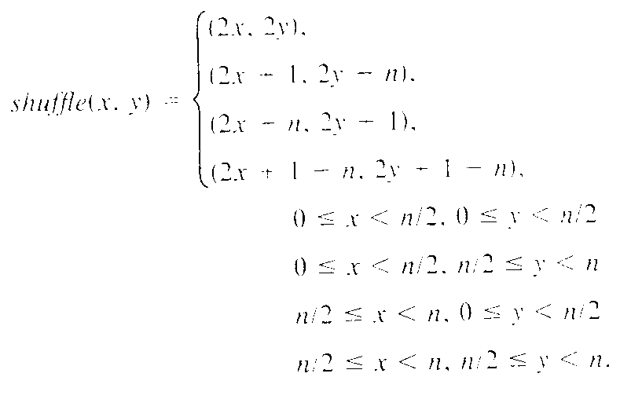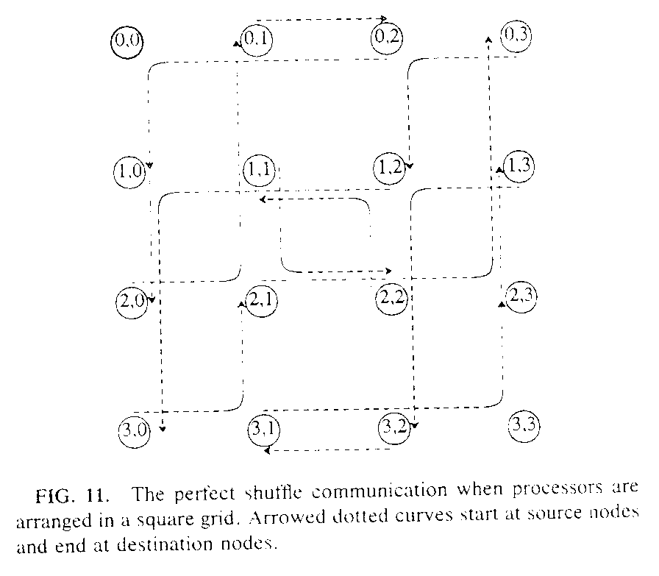

Created by : Chia-Mao Huang

Date : Sep. 14, 1999

